
Processes improvement in Plympton Park Day & Night Surgery (PPDNS)


Group 5
Somalika Uch
Benita Evelina Andriani
Thi Thu Trang Nguyen
Shahroz Khan
Trung Hieu Huynh
Contents
1. Executive Summary 3
2. Business Background 4
3. Analysis and Finding 4
3.1. Current Business Processes 4
3.1.1 Appointment Booking process 4
3.1.2 Patient Attendance Process 6
3.2. Improved Business Processes 8
3.2.1 Appointment Booking Process 8
3.2.2 Patient Attendance Process 11
4. Conclusion and Recommendations 13
5. References 17
6. Appendix 19
6.1. Interview Questions 19
6.2. Interviewee Profile 19
6.3. Interview Video and Transcript 19
6.4. Task Allocation 20
6.5. BPMN Diagrams 20
6.6. Minutes of Meetings 20

Executive Summary
This report represents a business process analysis in a general medical practice located in Plympton Park, Adelaide, South Australia, which focuses on internal process management and the service delivery model. GPs are working as an independent contractor rather than as an employee in clinic's contractor-based business model. The clinic makes money by giving general practitioners (GPs) clinical rooms, billing software, administrative personnel, and infrastructure so they can provide direct patient care.
It also highlights the key processes involved in this clinic such as Medicare claims processing, patient follow-ups, patient check-ins, consultations, patient attendance and appointment scheduling (online, over the phone, or in person) are among the key processes. Due to disruption in the processes, clinic is facing some difficulties such as an excessive dependence on multiple systems, software malfunctions, no back up plans and a shortage of general practitioner. Among those key processes, two of the key processes have been chosen to analyse further to identify the problems in the processes by which clinic face disruptions. After identifying the problems this report also provided some recommendations and risk associated while implementing the solution, to counter the problems. Tools like PAT CAT or PrimarySense for quality data extraction, Best Practice for patient management, and HotDoc for bookings are used to manage these procedures.
To increase efficiency, we have suggested some technical solutions to counter those challenges. The clinic is currently switching to more reliable systems. System redundancy tactics, GP recruitment collaborations, and lean-based enhancements to the check-in and scheduling processes are among the suggestions made in this research. BPMN 2.0 diagrams have been added to show the current processes and support process enhancements. The ultimate goal of this report is to provide practical and significant recommendations for process innovation that support administrative and clinical objectives.

Business Background
The business which we have targeted in our report belongs to a health care industry which is located in Plympton Park, Adelaide, South Australia. This is a general practice clinic, which offers multiple holistic health care solutions in Adelaide such as health assessment, pediatric medicine, vaccinations, men’s health, chronic disease management and women’s health. Furthermore, it also provides Minor surgical procedures, Immunisations, Adolescent health care, Preventative Medicine, Pre-employment medicals. In this service-based approach, general practitioners (GPs) function as independent contractors rather than employees. In exchange for providing GPs with consultation rooms, administrative assistance, nursing personnel, medical equipment, and software for patient and billing management, the clinic charges service fees for their operational cost.
The interviewee, Mr. Zeeshan, serves as a Practice Manager and holds a critical role in managing daily operations, overseeing technological integration, and supporting strategic decision-making. His insights were pivotal in understanding the clinic’s unique business model, technological dependencies, and process challenges. Zeeshan detailed key administrative and clinical workflows, highlighted the risk areas like software reliability and GP shortages, and discussed the clinic’s quality improvement procedures. He also shared the organization’s approach to performance evaluation, reliance on systems like HotDoc and Best Practice, and the broader limitations due to government policies and healthcare Labor shortages.
Zeeshan’s extensive knowledge of both clinical and administrative sides provided us enough information which was essential to map the current processes. Which helped us understanding the whole clinical process.

Analysis and Finding

3.1. Current Business Processes

3.1.1 Appointment Booking process
Plympton Park Day & Night Surgery (PPDNS) offers three methods for booking medical appointments: online via the HotDoc platform (a third-party service available on mobile devices and websites), over the phone, or in-person at reception. The booking process involves selecting the consultation type (e.g., standard, telehealth), choosing a doctor and time, providing personal information, and confirming the booking.

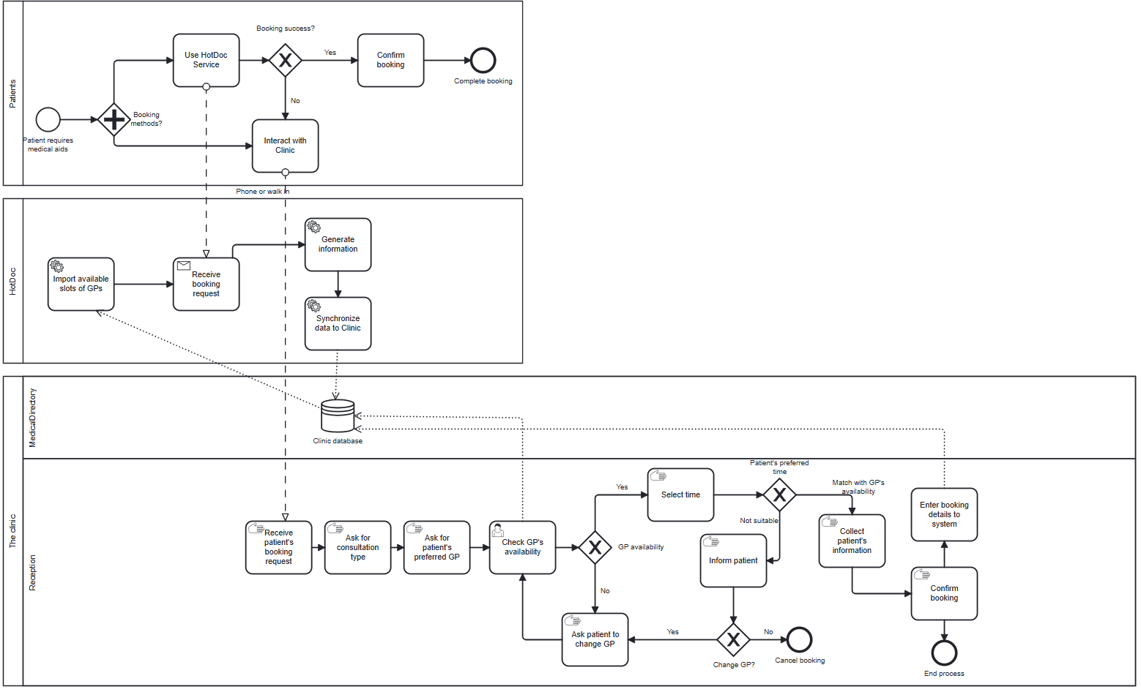
Figure 1- The diagram for Booking an Appointment at Plympton Park Day & Night Surgery

For HotDoc, patients complete these steps online, and the booking syncs automatically with the patient management software (MedicalDirector). For phone or in-person bookings, patients provide details to reception staff, who manually enter them into the software, verifying availability and confirming verbally. The clinic operates on a local server-client software model, with the server storing the clinical database and appointment schedule, accessed by staff on computers.
The interviewee shared that the software frequently experiences crashes, halting access to the appointment schedule in MedicalDirector. Staff cannot view or enter bookings during downtime, resorting to paper-based methods that are slow and error-prone. This leads to booking delays, cancellations, and rescheduling, which damage the clinic’s finances and reputation over time.
Another finding is the over-Reliance on HotDoc: PPDNS heavily depends on HotDoc for online bookings. Outages or delays in this third-party platform force patients to call or visit the clinic, leading to a spike in call volume. With a small team, this overwhelms reception staff, increasing waiting times for patients and reducing service quality. Long call times, according to the study, overwork staff members, lower their output, and create needless patient worry (Benites et al, 2024)
In addition, phone and in-person bookings require reception staff to manually enter details into MedicalDirector, including patient information, consultation type, and time slot. This process is time-consuming and prone to human errors (e.g., incorrect patient IDs or slot allocation), especially during peak call volumes. Errors can lead to scheduling conflicts or patient dissatisfaction, impacting service delivery.

Lastly, there is lack of automated booking confirmations: PPDNS does not send automated SMS or email confirmations to patients after booking, this gap increases the likelihood of late arrivals and non-attendance, disrupting the appointment schedule and reducing clinic efficiency.

3.1.2 Patient Attendance Process
The diagram below illustrates a BPMN model of the AS-IS Patient Attendance process, covering key stages from registration and check-in to consultation and post-visit follow-up. This diagram was developed based on insights gathered through an interview with the clinic representative and accurately reflects how the system operates in practice.
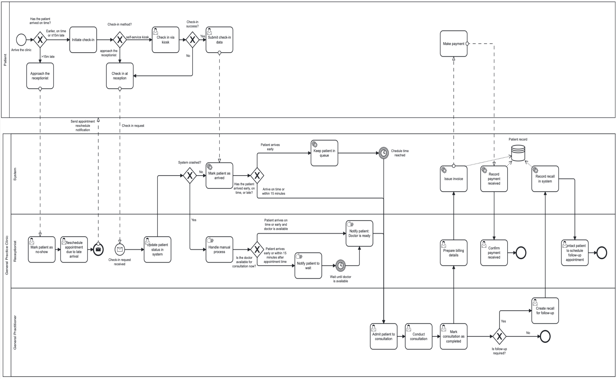
Figure 2. AS-IS BPMN Diagram of the Patient Attendance Process at Plympton Park Day & Night Surgery
Through analysis of this process, several system issues have been identified. When a patient arrives for their scheduled appointment, they are handled differently depending on their arrival time. Patients who are more than 15 minutes late must inform the receptionist, who manually updates their status in the MedicalDirector system by rescheduling or marking them as a no-show. There is no system-generated alert for late arrivals, which increases the risk of oversight and disrupts patient flow (MedicalDirector, 2016; Chiarini, 2020).
Patients can check in either via a self-service kiosk or at the reception desk. While kiosks aim to streamline the check-in process, some elderly patients find them difficult to use, necessitating staff assistance. Additionally, when the online booking platform (e.g., HotDoc) fails, receptionists face a sudden surge in manual phone and in-person requests, increasing their workload (Ratwani et al., 2018).
Once check-in is completed, patient status is updated in MedicalDirector, which displays the information in a virtual waiting room visible to General Practitioners (GPs). However, when the system crashes — a recurring issue — arrival status cannot be recorded, leading to communication breakdowns and delays in consultation (MedicalDirector, 2016).
Patients are then managed in a manual queue until their scheduled time. The clinic does not employ dynamic queueing or real-time adjustments, relying instead on staff to manage early arrivals, delays, and no-shows. This manual coordination results in inconsistent wait times and reduces operational efficiency (Chiarini, 2020).
During consultation, GPs rely on MedicalDirector to access patients’ medical histories and previous results. If the system is unavailable, some GPs may cancel appointments, especially for chronic cases, due to the lack of essential information (Adler-Milstein & Huckman, 2013). If a follow-up is needed, GPs must manually create a recall entry. Clinic staff later contact the patient by phone. There is no system enforcement or automation to ensure recall completion, increasing the likelihood of missed follow-ups (Cresswell & Sheikh, 2013).
Overall, the current patient attendance process remains semi-automated, relying heavily on staff to manage operational gaps. System crashes, manual queuing, fragmented billing workflows, and limited recall automation collectively reduce service consistency and operational performance. These challenges highlight the need for a more integrated, automated, and resilient patient attendance process, which will be addressed in the TO-BE model.

3.2. Improved Business Processes

3.2.1 Appointment Booking Process

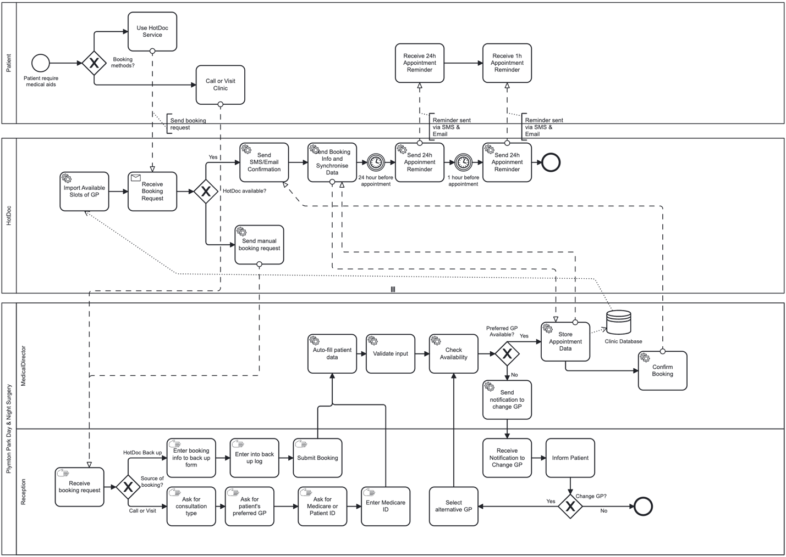
Figure 3. TO-BE BPMN Diagram of the Booking Appointment Process at Plympton Park Day & Night Surgery

In the TO-BE system, the appointment-booking process at PPDNS has been re-designed to address issues in the AS-IS system, including over-reliance on HotDoc, lack of automated booking confirmation, manual input data risks, and lack of backup process during platform or system downtime.
Currently, patients can book a request via two routes: online via HotDoc, or directly by phone call or in-clinic visit. The issue in the AS-IS process is a lack of an automated system for booking confirmation and reminders. We address this issue by automating this process by sending it accordingly. If HotDoc is available, booking details are passed through the system to send automated reminders and confirmations via SMS and email (24 hours and 1 hour before the appointment). These automated reminders are designed to reduce no-shows and improve patient attendance (Robotham et al., 2016).
Moreover, when HotDoc becomes unavailable or experiences system disruption, to reduce dependence on HotDoc in the AS-IS process, a backup channel is introduced. If patients are automatically redirected to call up the clinic and use a backup web form. Receptionists then receive this backup request and proceed to enter the patient's data into a simple web-based backup form and a temporary spreadsheet log for continuity of booking. Once it is done, the booking information will be submitted to MedicalDirector to proceed with the automated procedure. This addition prevents system bottlenecks and facilitates better control of patient flow during outages. It is aligned with best practices in the healthcare system in reducing workflow disruption caused by system downtime or disruption (Pan et al., 2024).
Furthermore, to prevent system unavailability and ensure reliable access, the TO-BE model for the PPDNS system is shifting towards a secure cloud-based system platform. This guarantees instant access across all devices, reducing the reliance on local servers, and improves the stability and scalability of the system during peak usage (Cresswell et al., 2021).
To reduce manual tasks and optimise data quality, we suggest improving systems that emphasise the use of unique identifiers and real-time validation to reduce error (Förstel et al., 2024). The receptionist will obtain necessary booking information like the type of consultation, preferred GP, and patient/Medicare ID. Patient details are automatically fetched and validated during entry of the ID, removing incorrect manual entries and improving data quality. Once the data is validated, MedicalDirector will automatically check the GP’s availability.
If the preferred GP cannot be booked or is unavailable, the system notifies the receptionist to inform the patient. The patient can decide if they agree to an alternative GP or to cancel the booking. If agreement is given, the receptionist helps select an alternative GP, and the system will proceed to recheck for availability, looping as required. If no selection is chosen (which is to cancel the booking), then the request to book will be terminated. This also emphasises the use of the automated system to reduce manual work (Robotham et al., 2016).
Finally, if the booking is successful, the system stores the booking details in the clinic database and informs the patient by sending SMS and email confirmation. The TO-BE model is designed to guarantee a stronger, more efficient, and patient-focused booking process that facilitates service continuity without relieving the pressure on the clinic staff.

3.2.2 Patient Attendance Process
Currently, the patient attendant process is experiencing inefficiency due to the manual management of patient late arrivals. It proposes enhancing the check-in system by integrating the check-in system with the appointment scheduler by automatically comparing the actual arrival time and the scheduled time. For instance, if the patient arrives over 15 minutes late, the system will change the status to no-show or will need to be rescheduled, alerting the GPs and staff. An automatic process will help to reduce human error, reduce the receptionist workload, and create a standardized workflow to handle the delay effectively, aligning with BPM principle (Buttigieg et al., 2016). Moreover, the automatic process will increase the quality of data capture, which can be used to analyze the patient arrival time for refining the reminder protocol (Coyle et al., 2019).
Initially, the self-service kiosk is used to improve the check-in process; however, elderly patients have difficulty using the system. Poor design of user interfaces in healthcare systems contributes to more errors and reduces user satisfaction (Jansson et al., 2022). To address the current issue, we suggest that the organization should redesign a user-friendly interface that has a large font, easy navigation icons, and multiple language support. Also, practices should assign one person to assist the patient check-in with patients who are unfamiliar with the process during the busy hours. Enhancing the check-in process in health care will reduce the bottleneck in reception, improving the overall flow efficiency (Coyle et al., 2019).
After the check-in process, the patient is currently experiencing inconsistent wait times and unpredictable service times. The organization suggested implementing the digital queue management feature, in which the patients are assigned a token number by the system, which is updated with real-time queueing status based on real-time arrival, no-show, or late arrivals. If the patient arrives early, the system features before appointment time, it automatically assigns the patient to the waiting room. When the time for consultation is up, the system will notify the patient with the status update for the patient to meet the doctor. This real-time visibility will help staff to have better management of the workload and proactively support rearrangement of the appointment or fill in the cancellation slots (Chen et al., 2016). The digital queuing system significantly contributes to increasing services provided to patients and operational efficiency, as well as aligning with BPM principles of process visibility and responsiveness (Gupta, 2013).
The follow-up is currently done manually by the admin staff and is facing inefficiency. It is recommended to enhance the system features by adding an automatic reminder for the GPs to set for follow-up in some health care conditions if needed, then the system will generate the follow-up appointment with the patient directly and allow the administrative staff to monitor the follow-up status in the central dashboard. Also, sending the confirmation for the data of the next appointment to the patient via SMS or Email with given choices to confirm or reschedule. In the case that the patient is having a conflict with the follow-up appointment, the receptionist will notify the patient and will assign the next available appointment until the schedule has been set. Automatic reminder and follow-up systems can help the patient to adhere to the treatment plan and contribute to better results for patients with chronic disease (Hamine et al., 2015).
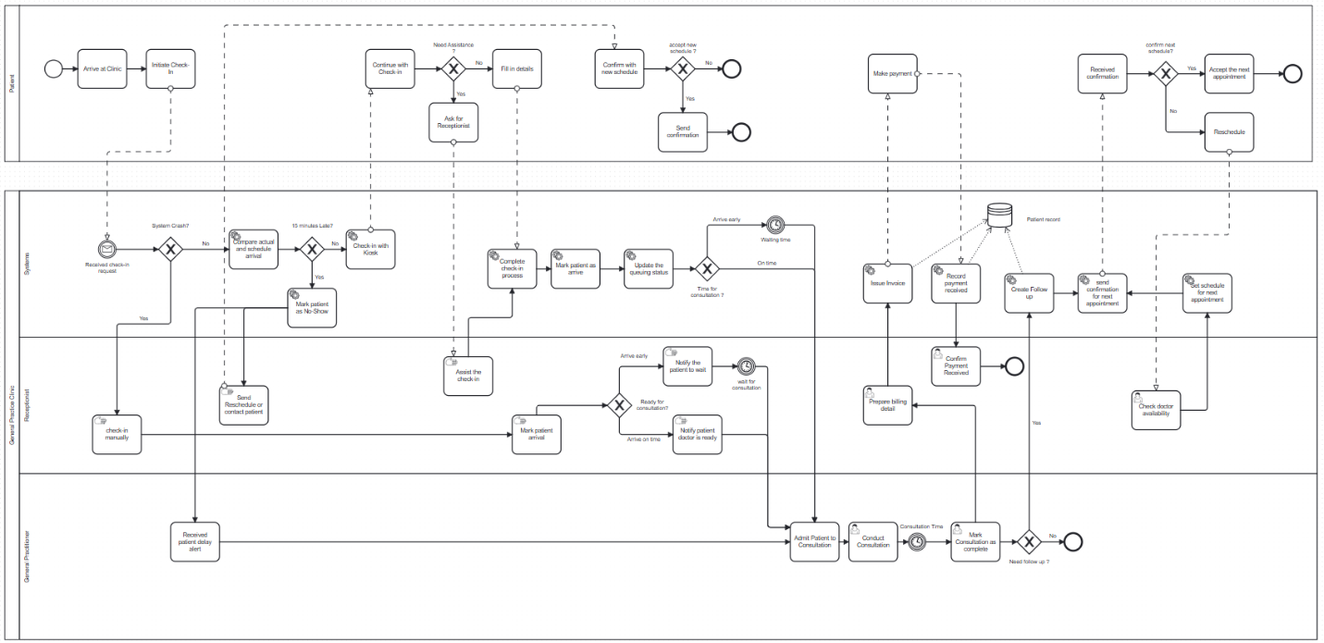
Figure 4. TO-BE BPMN Diagram of the Patient Attendance Process at Plympton Park Day & Night Surgery

Conclusion and Recommendations
Plympton Park clinic relies on digital tools to carry out operations, challenges such as workforce shortages, third-party service interruptions, and clinic dependency issues particularly regarding the availability of GP, are making its operations difficult. We have deeply analysed those concerns to address the current issues with a cost-effective solution by suggesting an upgrade in the current system with addition to some 3rd party software. The proposed solution can help the clinic to perform its operations efficiently. clinic's continuous dedication towards quality improvement shows a solid basis for future process improvements.
For the appointment booking process, the clinic should incorporate both online and manual booking methods to enhance the appointment scheduling process, guarantee consistent data submission, and lessen dependency on 3rd party platforms. To support reception employees and ensure workflow continuity in the event of system outages, a web-based backup solution should be implemented. Furthermore, data accuracy will be greatly increased by putting in place real-time validation of patient data, such as Medicare ID. GP availability verification can assist avoid scheduling conflicts and expedite the appointment-allocation process.
While the patient attendant process should use timestamped check-ins to automatically detect late arrivals to expedite patient attendance and lessen human workforce. To enhance communication, late patients can then be marked in the system and GPs will receive automated reminders. Installing easy-to-use kiosks to improve the self-check-in procedure would also ease front desk traffic. A virtual waiting area or token-based queue should be employed for real-time visibility to better manage patient flow. Setting up automated email or SMS reminders with links for patients to confirm or reschedule their appointments is another way to enhance follow-up care. Recall and follow-up status should be effectively monitored using a single dashboard. There should be a manual backup system in place during outages.
Based the recommendations to improve the current business process, the cost benefit and risk analysis for the organization to access whether it is worthwhile for investment.
Cost and Benefit Analysis
Currently company is using Best Practice and HotDoc, which we found the best software's for their operation, but some cost-effective additions can make the overall operations more efficient. The following table describe the fully integrated, reasonably priced solution to improve patient check-ins, appointment workflows, queue visibility, and follow-ups. The configuration ensures operational efficiencies while staying cost-effective.

Operational Area | Solutions Tools | Purpose | BP/HotDoc Integration | Cost Estimation (AUD) | Frequency
Booking Appointment | Advance plan of HotDoc | Auto-confirmations, online reservations, and patient reminders | Fully sync with Best Practice calendar | 250-300 | Monthly
 | SMS Credits | Reminders: 24h + 1h before appointment | Managed in HotDoc | Included in HotDoc Plan | –
Walk-In / Manual Booking | Best Practice | Appointments are entered manually by admin | – | Already Licensed | –
Self Check-in | Kiosk module of HotDoc | Timestamp logged in/ checked in via Tablet | Sync with BP Waiting room | Included in HotDoc plan | –
Detection of late arrival | Google App Script | Flag the queue, if check-in >15 mins late | Externaly used tool syncs with HotDoc timestamp logs | Free | _
 | Power Automate  (Optional) | Auto-notify reception/GPs via email | Integration capabilities with google forms | 150 | Monthly
Queue Management | Virtual waiting room of BP | Staff monitor the status of patient | Built-in in BP | Included in BP | _
 | Waitwhile  (Optional) | Visible digital queue with status updates and tokenized | No built-in integration; used independently | $23 | Monthly
Follow-Up Automation | Smart Recalls by HotDoc | Reschedule links with auto reminder | Built in BP recalls module | Included in HotDoc module | –
Backup Booking (System Downtime) | Google Forms | Backup form for appointments when HotDoc/BP is down | Manually entered | Free | –

Risk Associated
Despite providing a complete, integrated solution for clinical operations, Best Practice and HotDoc has risk of system outages, an excessive dependence on other technologies, data security issues, and rising SMS expenses. Also, personnel training gaps and synchronization problems might affect productivity.
Risk ID | Risk Description | Source | Impact | Risk Level
R1 | HotDoc/BP system outages could interfere with reservations, check-ins, and appointment visibility. | Over-reliance on digital platforms | There are a lot of missed appointments and workflow halts. | High
R2 | Inadequate synchronization or integration between HotDoc and Best Practice could result in duplicate reservations or inconsistent data. | Inaccurate calendar setting and alignment | Impacts trust and schedule accuracy. | Medium
R3 | If the backup Google Form system is not properly used or monitored, there will be no offline functionality during significant outages. | Infrequent use of manual backup | Unable to schedule appointments or keep track of visits | Medium
R4 | If scripts or timestamps are not followed or fail, late-arrival flagging will be delayed. | Google Script unmonitored | Disruption of patient flow and unprepared general practitioners | Medium
R5 | Inadequate training causes staff to misuse or mismanage recall/queue systems. | Change management, new process unfamiliarity | Lower follow-up adherence and inefficiencies | High
R6 | Data loss or invasion of privacy when integrating third-party tools or automating processes (e.g., Google Forms, Waitwhile) | Sensitive health data is handled by external systems. | Damage to one's reputation and legal standing | High
R7 | Inconsistent check-in experience for elderly at kiosks | Problems with the kiosk interface's usability | Front desk pressure and patient discontent | Medium
R8 | If not properly integrated, reliance on optional tools (such as Power Automate and Waitwhile) could lead to misunderstandings or overlap. | Several non-native tools are used | Inconsistency and administrative burden | Medium
R9 | Scalability constraints as patient volume increases without upgrading infrastructure or cloud hosting | Local server limitations | Administrative load and inconsistency | Medium

References
Adler-Milstein, J., & Huckman, R. S. (2013). The impact of electronic health record use on physician productivity. American Journal of Managed Care, 19(10), SP345–SP352.

Chiarini, A. (2020). Improving operational performance in outpatient clinics through Lean Healthcare tools. Leadership in Health Services, 33(1), 1–16. https://doi.org/10.1108/LHS-06-2019-0034

Cresswell, K. M., & Sheikh, A. (2013). Organizational issues in the implementation and adoption of health information technology innovations: An interpretative review. International Journal of Medical Informatics, 82(5), e73–e86. https://doi.org/10.1016/j.ijmedinf.2012.10.007

MedicalDirector. (2016). PracSoft User Guide (Version 3.17). Train IT Medical. https://trainitmedical.com.au/wp-content/uploads/2012/12/PracSoft_User_Guide-2016.pdf

Ratwani, R. M., Savage, E., Will, A., Fong, A., Karavite, D., Muthu, N., … & Adelman, J. (2018). Identifying electronic health record usability and safety challenges in pediatric settings. Health Affairs, 37(11), 1752–1759. https://doi.org/10.1377/hlthaff.2018.0699

Benites, J. A. C., Ramos, B. H. G., & Trujillo, E. A. H. (2024). Optimization of Appointment Scheduling for Hospitals Based on a Multilingual Virtual Assistant in an Instant Messaging Application. 2024 IEEE 4th International Conference on Advanced Learning Technologies on Education & Research (ICALTER), 1–4. https://doi.org/10.1109/ICALTER65499.2024.10819217

Buttigieg, S. C., Dey, P. K., & Gauci, D. (2016). Business process management in health care: current challenges and future prospects. Innovation and Entrepreneurship in Health, 1-13.

Chen, J., Li, K., Tang, Z., Bilal, K., & Li, K. (2016). A parallel patient treatment time prediction algorithm and its applications in hospital queuing-recommendation in a big data environment. IEEE Access, 4, 1767-1783.

Coyle, N., Kennedy, A., Schull, M. J., Kiss, A., Hefferon, D., Sinclair, P., & Alsharafi, Z. (2019). The use of a self-check-in kiosk for early patient identification and queuing in the emergency department. Canadian Journal of Emergency Medicine, 21(6), 789-792.

Gupta, D. (2013). Queueing models for healthcare operations. In Handbook of healthcare operations management: methods and applications (pp. 19-44). Springer.

Hamine, S., Gerth-Guyette, E., Faulx, D., Green, B. B., & Ginsburg, A. S. (2015). Impact of mHealth chronic disease management on treatment adherence and patient outcomes: a systematic review. Journal of medical Internet research, 17(2), e52.

Jansson, M., Liisanantti, J., Ala-Kokko, T., & Reponen, J. (2022). The negative impact of interface design, customizability, inefficiency, malfunctions, and information retrieval on user experience: A national usability survey of ICU clinical information systems in Finland. International Journal of Medical Informatics, 159, 104680.

Rodriguez-Martinez, M., Valdivia, H., Rivera, J., Seguel, J., & Greer, M. (2012). MedBook: A cloud-based healthcare billing and record management system. 2012 IEEE Fifth International Conference on Cloud Computing,

Singh, M. K., Pippal, S. K., & Sharma, V. (2025). Lightweight blockchain mechanism for secure data transmission in healthcare system. Biomedical Signal Processing and Control, 102, 107411.

Cresswell, K., Domínguez Hernández, A., Williams, R., & Sheikh, A. (2021). Cloud technology in healthcare: a qualitative study exploring key challenges and opportunities (Preprint). JMIR Human Factors, 9(1), 1–11. https://doi.org/10.2196/31246

Förstel, S., Förstel, M., Gallistl, M., Zanca, D., Eskofier, B. M., & Rothgang, E. M. (2024). Data quality in hospital information systems: Lessons learned from analyzing 30 years of patient data in a regional German hospital. International Journal of Medical Informatics, 192, 105636–105636. https://doi.org/10.1016/j.ijmedinf.2024.105636

Pan, D., Nilsson, E., & Rahman, S. (2024). A review of incidents related to health information technology in Swedish healthcare to characterise system issues as a basis for improvement in clinical practice. Health Informatics Journal, 30(3), 1–22. https://doi.org/10.1177/14604582241270742

Robotham, D., Satkunanathan, S., Reynolds, J., Stahl, D., & Wykes, T. (2016). Using digital notifications to improve attendance in clinic: systematic review and meta-analysis. BMJ Open, 6(10), e012116. https://doi.org/10.1136/bmjopen-2016-012116

Appendix

6.1. Interview Questions
- Can you introduce us to the overall business processes in your GP practice? What are the current core business processes that you think are important and helpful in operating the clinic? Can you describe each process flow in detail?
- Which departments or stakeholders are mostly involved in executing these processes, and how do they execute them?
- What business process do you think in your organization frequently causes delays or errors in delivering patient services?
- What are the weaknesses of the business processes you are involved with? And how do you cope with these problems? What is the most important thing you want to improve those weaknesses?
- Is there any on-going project which you are working on to improve Business Processes?
- What are the current technologies that are used to support each business process?
Do you currently use any digital tools to monitor workflows and staff performance?
- If you don’t mind and it is not confidential, what systems or technological tools that your company use for patient’s appointments, scheduling, payments/billing, and record management? How effective are these systems and tools?
- Which features do you think are helpful and which feature is required?
Do you apply any tool to modeling your business processes to have an overview of your operation? What is the advantage of the Business Process modelling in the healthcare sector?
- What sorts of process improvements or innovation that you would like to implement in the near future?
- What is the existing mechanism to receive feedback from customers/personnel for continuous improvement (CI)?
- How does your organization measure whether a process improvement is truly effective? Are there any KPIs or evaluation forms in place?

6.2. Interviewee Profile
General Practice Website: https://www.plymptonparkdns.com.au/
Address: https://www.plymptonparkdns.com.au/contact
Interviewee Name: Zeeshan Khan
Interview Position: Practice Manager
Interview Email Address: pm@plymptonparkdns.com.au

6.3. Interview Video and Transcript
Link to the interview Video: Discussion about Business Processes in Healthcare sector_default.mp4
Link to interview transcript: Interview Transcript.docx

6.4. Task Allocation
Tasks | Responsible Person
Executive Summary | Shahroz
Background | Shahroz
Current Business Process Analysis | Trung Hieu and Trang
As-Is Diagram | Trung Hieu and Trang
Improved Business Process Analysis | Lika and Benita
To-Be Diagram | Lika and Benita
Conclusion and Recommendation | Shahroz

6.5. BPMN Diagrams
- AS-IS Appointment Booking Process: AS-IS Booking process.bpmn
- TO-BE Appointment Booking Process: TO-BE Booking Process.bpmn
- AS-IS Patient Attendance Process: AS-IS_Patient_Attendance_Process.bpmn
- TO-BE Patient Attendance Process: TO-BE Diagram-Patient Attendance Process.bpmn

6.6. Minutes of Meetings
Meeting 1
Date: April 12th, 2025
Time: 9pm
Location: Zoom meeting
Chair/Coordinator: Trung Hieu

Attendees: Trung Hieu, Somalika, Shahroz, Benita
Agenda
- Waiting for Interviewer’s details to send invitations.
- Decide when to allocate the task to each member
- Zoom’s meeting including transcripts of interviews.
Post Meeting Action Items
- Each member needs to provide five questions covering all the assignment requirements which only final 10 questions to be asked, the rest will be backup

Meeting 2
Date: April 17th, 2025
Time: 9pm
Location: Zoom meeting
Chair/Coordinator: Trung Hieu

Attendees: Trung Hieu, Somalika, Shahroz, Benita, Trang
Agenda:
- Choosing the questions for interview
- Decide to obtain three business processes from the interview in detail
Post Meeting Action Items
- Send the interview questions list to interviewee

Meeting 3
Date: April 30th, 2025
Time: 12pm
Location: Zoom meeting
Chair/Coordinator: Trung Hieu

Attendees: Trung Hieu, Somalika, Shahroz, Benita, Trang
Agenda:
- Conduct the interview session with the interviewee
- Assigned the tasks for each member
- Set deadline for each deliverable

Post Meeting Action Items
- Provide the expected deliverable by the deadline

Meeting 4
Date: May 13th, 2025
Time: 2-4pm
Location: Mawson Lake Campus
Chair/Coordinator: Trung Hieu

Attendees: Trung Hieu, Somalika, Shahroz, Benita, Trang
Agenda:
- Finalized the report finding

Post Meeting Action Items
- Provide the expected deliverable by the deadline

